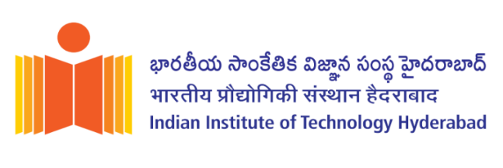

INDIAN INSTITUTE OF TECHNOLOGY HYDERABAD
Brochure for the M.Tech program on Techno-Entrepreneurship

Program and Curriculum
The Department of Entrepreneurship and Management (EM) invites application for its Master of Technology program in Techno-Entrepreneurship. The program aims to nurture entrepreneurial mind-set among engineering graduates and equip them with necessary skills and knowledge in technology and entrepreneurship. Furthermore, it will provide an ecosystem where the students can convert their entrepreneurial ideas into successful ventures. The program will be offered both in the Self-sponsored category and MoE (Ministry of Education) category from the July 2023 admission cycle.

Eligibility and Selection Criteria
The eligibility of the candidates to apply for the program and their selection will be according to the following criteria:
- Self-Sponsored Category

- Candidates with a B.Des, B.Arch, BTech or a BE degree (including early career professionals) with 60% marks or equivalent CGPA are eligible to apply.
- Candidates shortlisted must pass a written test and interview conducted by the Department.
- Mere fulfillment of the minimum educational qualifications does not necessarily entitle applicants to be called for written test and interview. The Institute reserves the right to call only the requisite number of potential candidates based on qualification and suitability.
- Failure to provide final proof of the qualifying undergraduate degree at the time of registration at IIT Hyderabad will lead to the cancellation of the applicant’s admission.
- Candidates selected in self-sponsored category are not eligible for fellowship.

- MoE Category

- Candidates having a valid GATE score in (Mechanical Engineering [ME], Aerospace Engineering [AE], Metallurgical Engineering [MT], Electrical Engineering [EE], Computer Science and Information Technology [CS], Civil Engineering [CE], Chemical Engineering [CH], Biotechnology [BT], Biomedical Engineering [BM]) disciplines are eligible to apply.
- Candidates shortlisted may go through a written test and/or interview conducted by the Department.
- The Institute reserves the right to call only the requisite number of GATE qualified candidates based on qualification and suitability.
- Candidates selected in MoE category are eligible for fellowship.
- Failure to provide the GATE score at the time of admission at IIT Hyderabad will lead to cancellation of the applicant’s admission.

Specific for MoE-IIT-BTech - IIT B.Tech graduates with CGPA of 8.0 or above without GATE score are eligible to apply. Department may conduct written test or interview for their selection.

Reservations
The reservation of seats in admissions under SC, ST, OBC, EWS categories and for persons with
disability (PWD) will be as per Government of India rules.

Procedure for Submitting the Application

Please fill and submit the online application form available on the Institute website: https://www.iith.ac.in/

Other relevant information
The written tests and interviews will tentatively be conducted in May-June 2023. Selection for the program will be based on a multistage shortlisting process (written test, short-writeup on a proposed entrepreneurship idea and interview)

Contact: For all queries regarding the application process, please email to mtech.admissions@em.iith.ac.in

