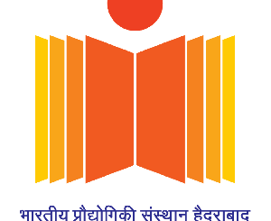
Online MTech Program (2021-22) Department of Electrical Engineering
IIT Hyderabad

Web: http://ee.iith.ac.in Contact: iith_ee_mtech_admission@iith.ac.in

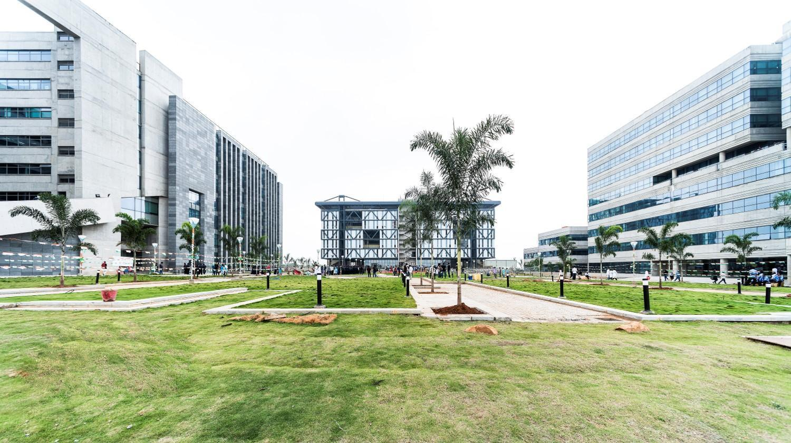

Program Overview

- Opportunity for online MTech program for working professionals
- Selection via written test/interview
- Duration of the program: Four semesters
- No difference in curriculum and degree to be awarded between MHRD funded and Online MTech candidates
- Non subsidised Program - No fellowship (even for GATE qualified students)
- Open for B.Tech/B.E degree holders having a first-class
- GATE qualification is not mandatory
- Total Credits to be completed: 48 – 50 Credits
- Conversion to MTech (TA-MHRD)/MTech (RA-MHRD) or vice versa is not allowed

Available MTech Programs and Eligibility to apply

- BE/B.Tech. with first-class (60% and above) and below disciplines.

M.Tech | BE/B.Tech Discipline | Written-Exam Syllabus
Microelectronics and VLSI | EE/ECE/EI or equivalent | EC Gate  http://gate.iitd.ac.in/Syllabus/EC.pdf

Indian Institute of Technology Hyderabad

IIT Hyderabad is one of the fastest-growing institutes in India and one among the 2nd generation of IITs started by the Govt. of India in 2008. As of date, IITH offers 10 B.Tech programs, 21 M.Tech programs, 3 M.Sc programs, 5 M.Phil programs, 1 M.Des program and Ph.D. programs in all branches of engineering, science, liberal arts and design. The very foundation of IIT Hyderabad is based on research and innovation. The vibrant research culture is evident from the number of patents and publications that IITH is generating. The institute has about 230 faculty and 2,500 students.

Electrical Engineering Department Overview

The Department of Electrical Engineering is the largest department at IIT Hyderabad with 218 B-Tech students, 124 M-Tech students and 167 PhD scholars. We have a team of 32 dedicated and dynamic faculty members (30 fulltime + 4 visiting). The Electrical Engineering department is known for its rich industrial collaborations and sponsor projects, across all departments in IIT Hyderabad.
Please visit https://ee.iith.ac.in to know more about research facilities, laboratories, MTech curriculum, and research area of various faculties.

Online M.Tech. Program

In view of the high demand in industries and research organizations for the highly skilled professionals and experts in specific domains, IITH had started an All course MTech program (ACM). After the success of the ACM program, the institute has further revamped it to Self-sponsored MTech program in 2020 to bring it at par with the regular MTech Program, to benefit the students. Now, the institute is taking this even further with the online MTech program that is tailored to the needs of working professionals.

MTech Programs

For the 2-year Online MTech program, candidates can select one of three programs at the time of application.

Microelectronics and VLSI
Research areas: VLSI/ULSI IC and system design, Nanoelectronics, Nano bio sensors, gas sensors, Nanophotonics, metamaterials, optoelectronic devices, 3DIC, MEMS-ASIC integration, Flexible electronics, Embedded systems, Analog, digital and mixed signal VLSI, Energy harvesting, ICs for wireless communication, Integrated microelectronic devices

Fee Structure

  - Refer https://www.iith.ac.in/academics/fee-structure/ for program fee structure.

Note
The department reserves the right to set any cutoff for the shortlisting of MTech applications. In addition, the department has all the rights to withdraw seats and not select anybody if no appropriate candidates are found. Mere eligibility does not imply that the candidate would be necessarily shortlisted for the written test/interview.

