

Evaluation of the M.Tech/M.Des Defense

 |  | Date :………………………
Name of the Student | : ………………………… | Roll No.:………..…………..
Department | : ………………………… | Stream :……..…………….
Program | : …………………………..
Details of Evaluation: (to be given by faculty)

Date of Evaluation : ………………………..

Semester : ……………………... Period ……………… Course Code & Name : ………… ……………………………………..…................ Title of Thesis : …………...……………………………………………………….. Grade Awarded Remarks (if any) ………..……………………………

Signature of the Supervisor /Guide Name:  Date: | Signature of the Internal Examiner Name:  Date: |  |  |  |  |  | Signature of the External Examiner Name:  Date:
Signature of the Chairman: Name:
Date:
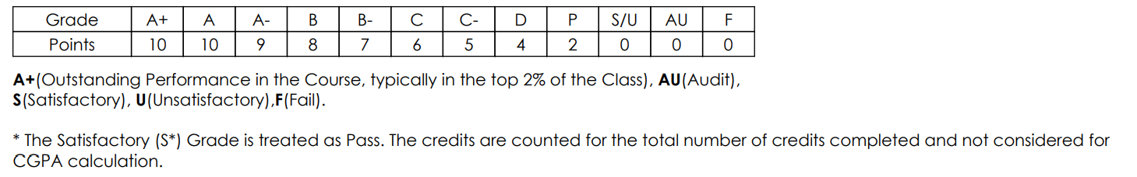

=============================================================================
For use of Academic section:
Date of uploading in AIMS …………….. Signature & Name

